
ATAR Biology

Unit 2: Topic 1
Week 19 – Cells as the basis of life

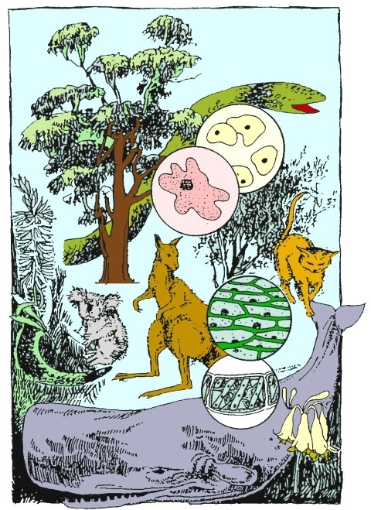
© SIDE

Student Study Notes

Unit Content
- Cells require energy inputs, including light energy or chemical energy in complex molecules, and matter, including gases, simple nutrients and ions, and removal of wastes, to survive.
- Prokaryotic and eukaryotic cells have many features in common, which is a reflection of their common evolutionary past, but prokaryotes lack internal membrane-bound organelles, do not have a nucleus, are significantly smaller than eukaryotes, usually have a single circular chromosome, and exist as single cells.

Metabolism describes the sum total of the physical and chemical processes by which cell components transform matter and energy needed to sustain life.

Cells as the basis of life
All living things are made of one or more cells so it is important to develop your understanding of these microscopic units of life. In this section, you will investigate cell structure and discover how to estimate cell size when viewed under the microscope.

The Discovery of Cells
Our knowledge of living cells began in the 17th century. Robert Hooke used the term 'cell' when he observed that microscopic pores in cork bark resembled a monk's living quarters or cell. Botanist, Robert Brown ﬁrst observed and described the cell nucleus in the 1830s.
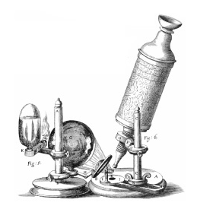

The Cell Theory

These discoveries led to the cell theory in 1839, which states that all organisms are made up of small units called cells. During the 20th century, the cell theory was further reﬁned as follows:
- All organisms are made up of cells.
- Cells carry out all the functions of life.
- Cells use energy for growth, repair and reproduction.
- Cells contain information for the next generation.
- Cells respond to changes in their environment
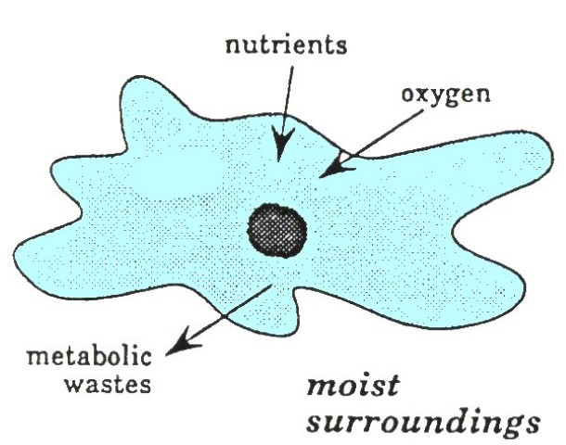
Cell requirements
All cells require energy and matter to survive.
Metabolism describes the sum total of the physical and chemical processes by which cell components transform matter and energy needed to sustain life.
© SIDE

Energy
Light energy is used by plant cells during photosynthesis to produce glucose from water and carbon dioxide. The chemical energy stored in glucose can then be used by the cell for metabolic activities.
Matter
Matter includes gases, nutrients, water, ions and metabolic wastes such as carbon dioxide which has to be removed.
Water
Water is vital for life and cells contain significant amounts of water. Water is important because it:
- is the solvent for chemical reactions in cells
- is used to transport materials to and from cells
- provides support for plant cells
Gases
Carbon dioxide is used by plant cells during photosynthesis. Oxygen is used by plant and animal cells to release the energy stored in glucose during the process of cellular respiration.
Nutrients and ions
Nutrients are the raw materials required by cells to provide matter and energy. Some plant cells may require minerals, such as nitrates and phosphorous, to manufacture proteins.
Waste removal
Cells need to remove the waste products of chemical reactions. This process is called excretion. During photosynthesis plant cells release excess oxygen as waste. During cellular respiration carbon dioxide is released as a waste product.
Eukaryotic and prokaryotic cells
Cells can be classified into two major groups: prokaryotes and eukaryotes.

Prokaryotes
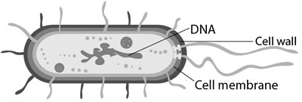
Prokaryotes (before nucleus) are microscopic organisms that do not possess a distinct nucleus or a nuclear membrane. The nuclear material, DNA, floats freely within the cytoplasm which is surrounded by a cell membrane and a cell wall as shown below.

Prokaryotes lack mitochondria or any other membrane-bound organelles.
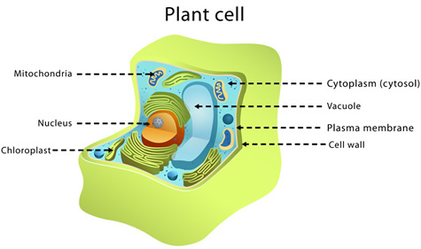
Members of the kingdom Monera, which includes bacteria and cyanobacteria (blue-green algae) are all prokaryotic organisms.
© WestOne
Eukaryotes
Eukaryotes (true nucleus) are organisms whose cells possess distinct membrane bound organelles including the nucleus and mitochondria. Members of the four kingdoms Plant, Animal, Fungi and Protista are all eukaryotic organisms.
© WestOne

Metabolic processes
Photosynthesis
The ultimate source of energy used to power life processes is solar energy and plants convert this energy into a useable form for themselves and other life forms. Plants produce their food through photosynthesis. This is the process where plants use the energy from the sun to combine carbon dioxide and water which produces glucose (a simple sugar) and oxygen. This occurs in the chloroplasts of the cell.
The word equation for photosynthesis is:

The role of photosynthesis is to build complex substances from simple substances taken in by the plant as shown below.

Simple substances taken in | Complex substances built
carbon dioxide  water  minerals, e.g. nitrates | carbohydrates  proteins  lipids

Cellular respiration
Living cells require energy and this energy is obtained through cellular respiration. Cellular respiration can be either aerobic or anaerobic. Aerobic respiration occurs in the presence of oxygen and occurs in the mitochondria. If oxygen is not readily available, respiration is anaerobic.
The word equation for aerobic respiration is:

glucose + oxygen → energy + carbon dioxide + water

When glucose reacts with oxygen, carbon dioxide, water and energy are produced. Some this energy is lost as heat and some is stored as adenosine triphosphate (ATP). Anaerobic respiration (without oxygen) produces less energy.

We will cover these processes in more detail in Topic 3.

Other examples of metabolic reactions include protein synthesis and the conversion of glucose into complex carbohydrates.

PRACTICE QUESTIONS:

Three students studied the image below.

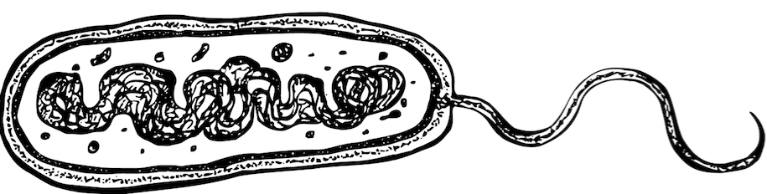

Each student made one statement:
- Student 1 - “It’s a bacterial cell – The arrangement of the DNA tells me this.”
- Student 2 – “It’s prokaryotic – I know this because it has a nucleoid region.”
- Student 3 – “It’s eukaryotic – Only eukaryotes have flagella.”

1. Who was correct?

- Only student 1.
- Students 1 and 2.
- Only student 3.
- Students 1 and 3.

2. The cell theory states that

  - All organisms are composed of cells and cell products and all cells result from reproduction of existing cells.
  - All cells carry out respiration and some of the energy released is used for the reproduction of cells.
  - All cells require nutrients which are then used for cellular respiration.
  - The cells of all organisms are very small, have the same basic structure and contain similar organelles.

3. Water is vital for life and most organisms contain significant amounts of water. Suggest two reasons why water is important for life.

4. Draw a diagram to show the inputs and outputs required by a cell.

Use your text or other resources to answer the following questions.
5. Do the following organisms have prokaryotic or eukaryotic cells?
Organism | Cell type
bacteria
koala
human
yeast
algae
6. Answer the following questions by selecting the correct options.
- Using the five kingdom system of classification, identify the kingdom whose organisms are prokaryotes:

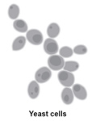
b) Using the five kingdom system of classification, identify the kingdom(s) whose organisms are eukaryotes:
© WestOne

c) Yeast and bacteria are both simple unicellular organisms. Why would you classify yeast as a eukaryote and bacteria as a prokaryote? Highlight the appropriate reason/s below.
- Yeast cells do not have a distinct membrane-bound nucleus
- Yeast cells have a distinct membrane-bound nucleus
- Bacteria have membrane-bound organelles
- Bacteria lack membrane-bound organelles

d) Cyanobacteria (blue-green algae) contain chlorophyll and are able to photosynthesise. Why are these organisms not placed in the Plant kingdom? Highlight the appropriate reason/s below.

- Cyanobacteria are prokaryotes and plants are eukaryotes
- Cyanobacteria are eukaryotes and plants are prokaryotes
- Unlike plant cells, cyanobacteria lack membrane bound organelles
- Unlike plant cells, cyanobacteria nuclear material is not membrane bound
- Unlike plant cells, cyanobacteria nuclear material is membrane bound

Photosynthesis is the process of using light energy to convert carbon dioxide and water into carbohydrates. You will learn more about this chemical process in Topic 3.
1. During photosynthesis, sunlight is captured by the c _____________ in the chloroplasts of green plants and this energy is used to manufacture g ______ (sugar) from carbon dioxide and w _________.
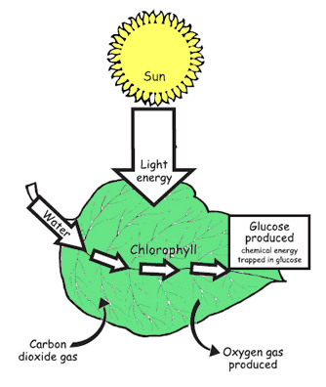
© SIDE
The whole process of photosynthesis is usually written as a word equation:
carbon dioxide + water 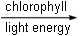 glucose + oxygen
2. In which cells of a plant would you expect to find the most chloroplasts?
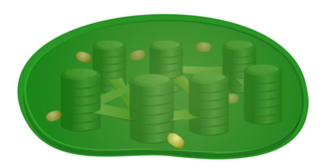
© WestOne
Select the correct options from below.
- root cells
- stem cells
- leaf cells

